

**MSPM’S**

**Deogiri Institute of Engineering and Management Studies, Aurangabad**

**Department of Computer science and engineering**

**Report on**

**Dell Inspiron and Hp Model**

Submitted by

**Gunjan Mehta (26123)**

**Vipul Hiwarde (26124)**

Under the Guidance of

**Prof. Durole sir**

Department of computer science and engineering

(Deogiri Institute of Engineering and Management Studies)

2019-2020

**Processor**

* A processor is the logic circuitry that responds to and processes the basic instructions that drive a computer. The four primary functions of a processor are fetch, decode, execute and write back.
* The basic elements of a processor:
* The arithmetic logic unit (ALU), which carries out arithmetic and logic operations on the operands in instructions.
* The floating point unit (FPU), also known as a math coprocessor or numeric coprocessor, a specialized coprocessor that manipulates numbers more quickly than the basic microprocessor circuitry can.

Registers, which hold instructions and other data.

* L1 and L2 cache memory. Their inclusion in the CPU saves time compared to having to get data from random access memory (RAM).

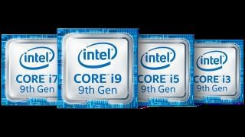

Most processors today are multi-core, which means that the IC contains two or more processors for enhanced performance, reduced power consumption and more efficient simultaneous processing of multiple tasks (see: parallel processing). Multi-core set-ups are similar to having multiple, separate processors installed in the same computer, but because the processors are actually plugged into the same socket, the connection between them is faster.

The term processor is used interchangeably with the term central processing unit (CPU), although strictly speaking, the CPU is not the only processor in a computer. The GPU (graphics processing unit) is the most notable example but the hard drive and other devices within a computer also perform some processing independently. Nevertheless, the term processor is generally understood to mean the CPU.

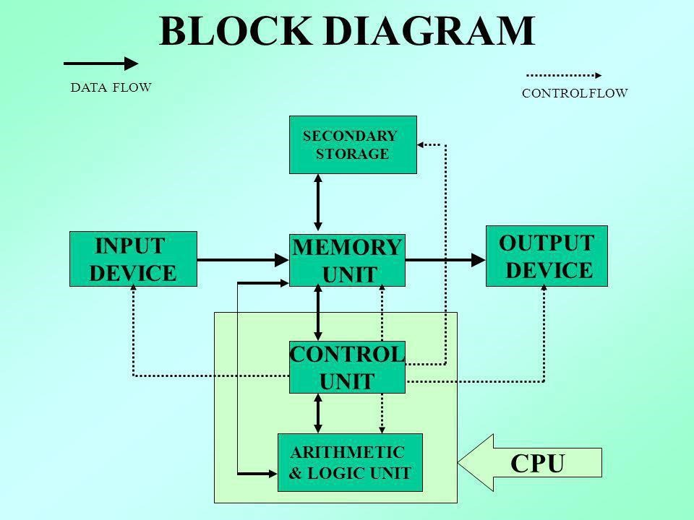

The processor in a personal computer or embedded in small devices is often called a microprocessor. That term simply means that the processor's elements are contained on a single integrated circuitry (IC) chip.

The two main competitors in the processor market are Intel and AMD.

# Architecture

The word "architecture" typically refers to building design and construction. In the computing world, "architecture" also refers to design, but instead of buildings, it describes the design of computer systems. Computer architecture is a broad topic that includes everything from the relationship between multiple computers (such as a "client-server" model) to specific components inside a computer.

The most important type of hardware design is a computer's processor architecture. The design of the processor determines what software can run on the computer and what other hardware components are supported. For example, Intel's x86 processor architecture is the standard architecture used by most PCs

By using this design, computer manufacturers can create machines that include different hardware components, but run the same software. Several years ago, Apple switched from the PowerPC architecture to the x86 architecture to make the Macintosh platform more compatible with Windows PCs.

The architecture of the motherboard is also important in determining what hardware and software a computer system will support. The motherboard design is often called the "chipset" and defines what processor models and other components will work with the motherboard. For example, while two motherboards may both support x86 processors, one may only work with newer processor models. A newer chipset may also require faster RAM and a different type of video card than an older model.

NOTE: Most modern computers have 64-bit processors and chipsets, while earlier computers used a 32-bit architecture. A computer with a 64-bit chipset supports far more memory than one with a 32-bit chipset and can run software designed specifically for 64-bit processors.

# GPU

(Graphics Processing Unit) A programmable logic chip (processor) specialized for display functions. The GPU renders images, animations and video for the computer's screen. GPUs are located on plug-in cards, in a chipset on the motherboard or in the same chip as the CPU. A GPU performs parallel operations. Although it is used for 2D data as well as for zooming and panning the screen, a GPU is essential for smooth decoding and rendering of 3D animations and video. The more sophisticated the GPU, the higher the resolution and the faster and smoother the motion in games and movies. GPUs on stand-alone cards include their own memory, while GPUs built into the chipset or CPU chip share main memory with the CPU. Not Just Graphics Processing Since GPUs perform parallel operations on multiple sets of data, they are increasingly used as vector processors for non-graphics applications that require repetitive computations. For example, in 2010, a Chinese supercomputer achieved the record for top speed using more than seven thousand GPUs in addition to its CPUs.

## 

**Graphics Hardware Locations**

In a PC, graphics rendering originally took place in the CPU. Over time, functions were offloaded to separate circuits and then to GPUs either in separate cards, the PC's chipset or the CPU chip itself. See display adapter, integrated graphics and integrated GPU.

## **An Integrated GPU**

This Trinity chip from AMD integrates a sophisticated GPU with four cores of x86 processing and a DDR3 memory controller. Each x86 section is a dual-core CPU with its own L2 cache.

## **History of GPUs**

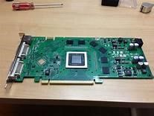Specialized chips for processing graphics have existed since the dawn of video games in the 1970s. Graphics processing units came to high performance enterprise computers in the late 1990s, and NVIDIA introduced the first GPU for personal computers, the GeForce 256, in 1999. Over time, the processing power of GPUs made the chips a popular choice for other resource-intensive tasks unrelated to graphics. Early applications included scientific calculations and modeling; by the mid-2010s, GPU computing also powered machine learning and artificial intelligence software.

In 2012, NVIDIA released a virtualized GPU, which offloads graphics processing power from the server CPU in a virtual desktop infrastructure. Graphics performance has traditionally been one of the most common complaints among users of virtual desktops and applications, and virtualized GPUs aim to address that problem.

### **RAM (Random Access Memory)**

RAM (Random Access Memory) is the hardware in a computing device where the operating system (OS), application programs and data in current use are kept so they can be quickly reached by the device's processor. RAM is the main memory in a computer, and it is much faster to read from and write to than other kinds of storage, such as a hard disk drive (HDD), solid state drive (SSD) or optical drive.

Random Access Memory is volatile. That means data is retained in RAM as long as the computer is on, but it is lost when the computer is turned off. When the computer is rebooted, the OS and other files are reloaded into RAM, usually from an HDD or SSD.

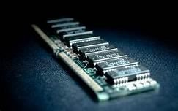

***What Random Access Memory is used for?***

Because of its volatility, Random Access Memory can't store permanent data. RAM can be compared to a person's short-term memory, and a hard drive to a person's long-term memory. Short-term memory is focused on immediate work, but it can only keep a limited number of facts in view at any one time. When a person's short-term memory fills up, it can be refreshed with facts stored in the brain's long-term memory.

A computer also works this way. If RAM fills up, the computer's processor must repeatedly go to the hard disk to overlay the old data in RAM with new data. This process slows the computer's operation.

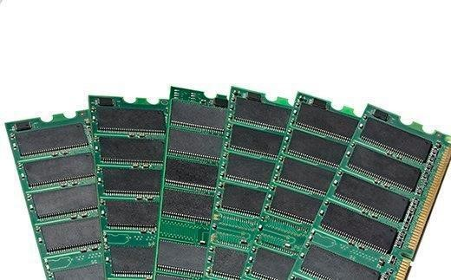

A computer's hard disk can become completely full of data and unable to take any more, but RAM won't run out of memory. However, the combination of RAM and storage memory can be completely used up.

How does RAM work?

The term *random access as applied to RAM comes from the fact that any storage location, also known as any memory address, can be accessed directly.* Originally, the term *Random Access Memory was used to distinguish regular core memory from offline memory.*

Offline memory typically referred to magnetic tape from which a specific piece of data could only be accessed by locating the address sequentially, starting at the beginning of the tape. RAM is organized and controlled in a way that enables data to be stored and retrieved directly to and from specific locations.

Other types of storage -- such as the hard drive and CD-ROM -- are also accessed directly or randomly, but the term *random access isn't used to describe these other types of storage.*

RAM is similar in concept to a set of boxes in which each box can hold a 0 or a 1. Each box has a unique address that is found by counting across the columns and down the rows. A set of RAM boxes is called an array, and each box is known as a cell.

To find a specific cell, the RAM controller sends the column and row address down a thin electrical line etched into the chip. Each row and column in a RAM array has its own address line. Any data that's read flows back on a separate data line.

RAM is physically small and stored in microchips. It's also small in terms of the amount of data it can hold.

A typical laptop computer may come with 8 gigabytes of RAM, while a hard disk can hold 10 terabytes.

RAM microchips are gathered together into memory modules, which plug into slots in a computer's motherboard.

Most PCs enable users to add RAM modules up to a certain limit. Having more RAM in a computer cuts down on the number of times the processor must read data from the hard disk, an operation that takes longer than reading data from RAM. RAM access time is in nanoseconds, while storage memory access time is in milliseconds. Types of Random Access Memory 14 RAM comes in two primary forms:

***Dynamic Random Access Memory (DRAM)*** makes up the typical computing device's RAM and, as was previously noted, it needs that power to be on to retain stored data.

Each DRAM cell has a charge or lack of charge held in an electrical capacitor. This data must be constantly refreshed with an electronic charge every few milliseconds to compensate for leaks from the capacitator. A transistor serves as a gate, determining whether a capacitor's value can be read or written.

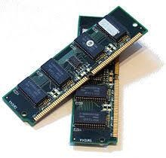

***Static Random Access Memory (SRAM)*** also needs constant power to hold on to data, but it doesn't need to be continually refreshed the way DRAM does.

In SRAM, instead of a capacitor holding the charge, the transistor acts as a switch, with one position serving as 1 and the other position as 0. Static RAM requires several transistors to retain one bit of data compared to dynamic RAM which needs only one transistor per bit. As a result, SRAM chips are much larger and more expensive than an equivalent amount of DRAM.

However, SRAM is significantly faster and uses less power than DRAM. The price and speed differences mean static RAM is mainly used in small amounts as cache memory inside a computer's processor.

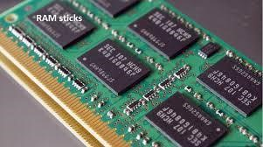

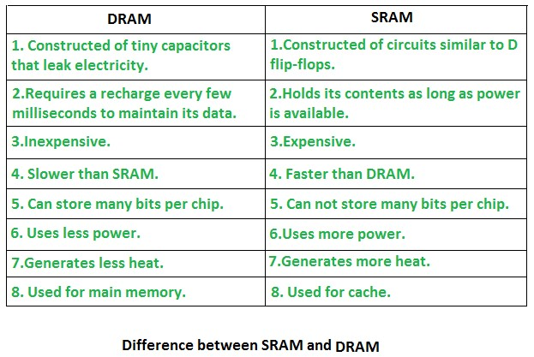

### **History of RAM: RAM vs. SDRAM**

RAM was originally asynchronous because the RAM microchips had a different clock speed than the computer's processor. This was a problem as processors became more powerful and RAM couldn't keep up with the processor's requests for data.

In the early 1990s, clock speeds were synchronized with the introduction of synchronous dynamic RAM, or SDRAM. By synchronizing a computer's memory with the inputs from the processor, computers were able to execute tasks faster.

However, the original single data rate SDRAM (SDR SDRAM) reached its limit quickly. Around the year 2000, double data rate synchronous Random Access Memory (DDR SRAM) was developed. This moved data twice in a single clock cycle, at the start and the end.

DDR SDRAM has evolved three times, with DDR2, DDR3 and DDR4, and each iteration has brought improved data throughput speeds and reduced power use. However, each DDR version has been incompatible with earlier ones because, with each iteration, data is handled in larger batches.

### **GDDR SDRAM**

### 

Graphics double data rate (GDDR) SDRAM is used in graphics and video cards. Like DDR SDRAM, the technology enables data to be moved at various points in a CPU clock cycle. However, it runs at higher voltages and has less strict timing than DDR SDRAM.

With parallel tasks, such as 2D and 3D video rendering, tight access times aren't as necessary, and GDDR can enable the higher speeds and memory bandwidth needed for GPU performance.

Similar to DDR, GDDR has gone through several generations of development, with each providing more performance and lower power consumption. GDDR6 is the latest generation of graphics memory.

## ***RAM vs. ROM***

Read-only memory, or ROM, is computer memory containing data that can only be read, not written to. ROM contains boot-up programming that is used each time a computer is turned on. It generally can't be altered or reprogrammed.

The data in ROM is nonvolatile and isn't lost when the computer power is turned off.

As a result, read-only memory is used for permanent data storage. Random Access Memory, on the other hand, can only hold data temporarily. ROM is generally several megabytes of storage, while RAM is several gigabytes.

Trends and future directions

Resistive Random Access Memory (RRAM or ReRAM) is nonvolatile storage that can alter the resistance of the solid dielectric material it's composed of. ReRAM devices contain a memristor in which the resistance varies when different voltages are applied. ReRAM creates oxygen vacancies, which are physical defects in a layer of oxide material. These vacancies represent two values in a binary system, similar to a semiconductor's electrons and holes.

ReRAM has a higher switching speed compared to other nonvolatile storage technologies, such as NAND flash. It also holds the promise of high storage density and less power consumption than NAND flash, making ReRAM a good option for memory in sensors used for industrial, automotive and internet of things applications.

### **Storage**

Data storage is the collective methods and technologies that capture and retain digital information on electromagnetic, optical or silicon-based storage media. Storage is a key component of digital devices, as consumers and businesses have come to rely on it to preserve information ranging from personal photos to business-critical information.

Storage is frequently used to describe the devices and data connected to the computer through input/output (I/O) operations, including hard disks, flash devices, tape systems and other media types.

**Why data storage is important?**

Underscoring the importance of storage is a steady climb in the generation of new data, which is attributable to big data and the profusion of internet of things (IOT) devices. Modern storage systems require enhanced capabilities to allow enterprises to apply machine learning-enabled artificial intelligence (AI) to capture this data, analyze it and wring maximum value from it.

Larger application scripts and real-time database analytics have contributed to the advent of highly dense and scalable storage systems, including high performance computing storage, converged infrastructure, compostable storage systems, hyper-converged storage infrastructure, scale-out and scale up network-attached storage (NAS) and object storage platforms.

**How data storage works?**

The term *storage may refer both to a user's data generally and, more specifically, to the integrated hardware and software systems used to capture, manage and prioritize the data. This includes information in applications, databases, data warehouses, archiving, backup appliances and cloud storage.*

Digital information is written to target storage media through the use of software commands. The smallest unit of measure in a computer memory is a bit, described with a binary value of 0 or 1, according to the level of electrical voltage contained in a single capacitor. Eight bits make up one byte.

Other capacity measurements to know are:

* kilobit (Kb)
* megabit (Mb)
* gigabit (Gb)
* terabit (Tb)
* petabit (Pb)
* exabit (Eb)

Larger measures include:

* kilobyte (KB) equal to 1,024 bytes
* megabyte (MB) equal to 1,024 KB

### HP 15q

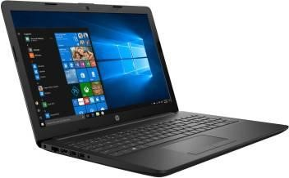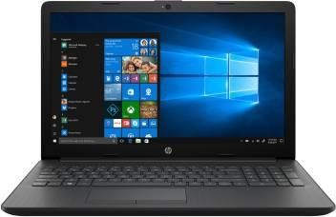

**Specifications**

**General**

|  |  |
| --- | --- |
| Sales Package •Laptop, Battery, Power Adaptor, User Guide,  Warranty Documents  Model Number •15q-ds0029TU | |
| Part Number | •6DT09PA |
| Series | •15q |
| Color | •Sparkling Black |
| Type | •Laptop |
| Suitable For | •Processing & Multitasking |
| Battery Backup | •Up to 7 hours |
| Power Supply | •65 W AC Adapter |
| Battery Cell | •3 cell |
| MS Office | •Yes |

## **Processor and Memory Features**

|  |  |
| --- | --- |
| Processor Brand | •Intel |
| Processor Name | •Core i5 |
| Processor  Generation | •7th Gen |
| SSD | •No |
| RAM | •8 GB |
| RAM Type | •DDR4 |
| HDD Capacity | •1 TB |
| Processor Variant | •7200U |
| Clock Speed | •2.5 GHz with Turbo Boost Up to 3.1 GHz |
| Cache | •3 MB |
| RPM | •5400 |

Graphic Processor •Intel Integrated HD 620

Number of Cores •2

## **Operating System**

OS •64 bit

Architecture

Operating •Windows 10 Home

System

System •64 bit

Architecture

## **Port and Slot Features**

|  |  |
| --- | --- |
| Mic In | •Yes |
| RJ45 | •Yes |
| USB Port | •1 x USB 2.0, 2 x USB 3.1 |
| HDMI Port | •1 x HDMI Port (v1.4b) |
| Multi Card | •3-in-1 Card Reader (SD, SDHC, SDXC) |

Slot

## **Display and Audio Features**

Touchscreen •No

|  |  |
| --- | --- |
| Screen Size | •39.62 cm (15.6 inch) |
| Screen  Resolution | •1920 x 1080 Pixel |
| Screen Type | •Full HD LED Backlit Display |
| Speakers | •Built-in Dual Speakers |
| Internal Mic | •Built-in Microphone |

## **Connectivity Features**

|  |  |
| --- | --- |
| Wireless  LAN | •IEEE 802.11b/g/n |
| Bluetooth | •v4.2 |
| Ethernet | •Integrated 10/100/1000 Gigabit LAN |

## **Dimensions**

Dimensions •376 x 246 x 22.5 mm

Weight •2.04 kg

## **Additional Features**

|  |  |
| --- | --- |
| Disk Drive | •CD/DVD writer |
| Web Camera | •HP True Vision HD Webcam |
| Read/Write  Speed | •8x |
| Keyboard | •Full Size Island Style Keyboard |
| Pointer Device | •Multi Gesture Touchpad |
| Recovery  Options | •Recovery Manager Installer for Windows 10 |
| Included  Software | •HP Audio Switch, HP Support Assistant, Microsoft  Office Home and Student 2016 |
| Additional | •Li-ion Battery |

Features

**Configuration of dell i5 model**

Display and Configuration There is a 2.3GHz Intel Core i5-6200U (6th generation) processor which is responsible for driving the system in a stable manner. For further assistance, there is an 8GB DDR3 RAM along with its friend AMD 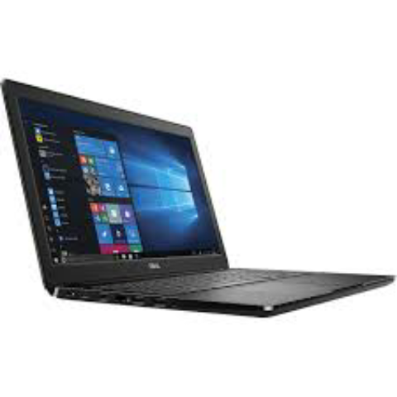Radeon R5 M335 gra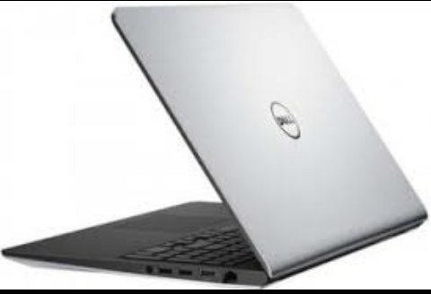phics engine.

**Processor architecture for Dell inspiron**

The architecture of a processor chip is a description of its basic components and of its basic operations. Each processor family has its own architecture. Assembly language is a programming view of the architecture of a particular processor. Each type of processor has its own assembly language.

When you study an assembly language, you study the architecture of a particular processor. The study of any assembly language increases your professional understanding of computers. These notes are about the MIPS processor, which is a nice processor to study. The concepts in MIPS assembly are universal.

These notes discuss assembly language from a computer science perspective. They explain what is going on in a computer system at the assembly language level. This is a view that is above the electronic view of computer architecture, but is below the operating systems view of the computer system.

**Reviews of laptops best for architecture aspirants**

* Microsoft Surface Book 2. Microsoft Surface book is one of the favorite laptops among Architects right now.
* Lenovo ThinkPad P71.
* Dell Inspiron G5587 Laptop.
* Acer Flagship 17.3″ 2019 Model.
* ASUS S510UN.
* HP ZBook 15 G4 Mobile Workstation.
* Lenovo 330 Idea pad.
* MSI WE73.

**Instruction set for Dell inspiration**

The instruction set provides commands to the processor, to tell it what it needs to do. The instruction set consists of addressing modes, instructions, native data types, registers, memory architecture, interrupt, and exception handling, and external I/O.

An example of an instruction set is the x86 instruction set, which is common to find on computers today. Different computer processors can use almost the same instruction set while still having very different internal design. Both the Intel Pentium and AMD Athlon processors use nearly the same x86 instruction set.

An instruction set can be built into the hardware of the processor, or it can be emulated in software, using an interpreter. The hardware design is more efficient and faster for running programs than the emulated software version.

Examples of instruction set

ADD - Add two numbers together.

COMPARE - Compare numbers.

IN - Input information from a device, e.g., keyboard.

JUMP - Jump to designated RAM address.

JUMP IF - Conditional statement that jumps to a designated RAM address.

LOAD - Load information from RAM to the CPU.

OUT - Output information to device, e.g., monitor.

STORE - Store information to RAM

Set up your computer

Connect the power adapter and press the power button.

**Dell Laptops with Core i5 Processor List Latest Price**

Dell 15 3576 (B566102WIN9) (Intel Core i5 (8th Gen) 4GB 1TB HDD Windows) Rs. 38,666

Dell Inspiron 3567 (i5 7th Gen/4GB/1TB/DOS) Rs. 48,970

Dell 14 3478 (B552508UIN9) (Intel Core i5 (8th Gen) 8GB 1TB HDD Linux)

**Functionalities of dell inspiron i5**

Dell Inspiron 15 3542 4th Gen Intel Core i5 is a mid-range laptop meant for personal as well as professional users. It runs on Windows 8.1 64-bit OS, a dual-core 1.7 GHz Intel Core i5 processor and Intel HD graphics 4400 processor

**COMPARISON BASED ON DIFFERENCES**

**MULTIMEDIA Dell Inspiron HP 15q**

**Processor type intel i5 8gen intel i5 7gen**

**Processor Variant 6200U 7200U**

**Clock Speed 2.3GH 2.5GH**

**Ram Type DDR3 DDR4**

**Color silver Sparkling black**

**Weight 2.2kg 2.04kg**

**SSD Yes No**